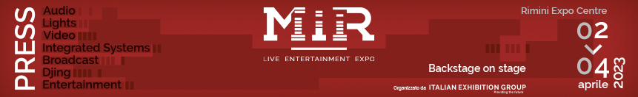

press release
(English translation)

TO MIR 2023 debuts MIR CLUB PROJECT, A PLACE OF ACTIVE PARTICIPATION to CREATE SYNERGIES AND NETWORK WITH ARTISTS AND EXPERTS

- In collaboration with content partner Music Innovation Hub, MIR CLUB welcomes all professionals and enthusiasts of live entertainment
- Includes an exhibition area, auditorium, networking corners and live performances.
- A full calendar of events, meetings, and conferences in CLUB Arena on topics such as passion, sustainability and technological innovation

www.mirtechexpo.com

Rimini, 23 March 2023 – Dedicated to all makers in the world of music and entertainment, MIR CLUB is the brand new, exclusive project making its debut at MIR 2023, the event gathering professionals and enthusiasts of live entertainment organised by Italian Exhibition Group, taking place from April 2-4 at the Rimini Expo centre.
MIR CLUB – born from a collaboration with content partner Music Innovation Hub, the pioneering vertical social enterprise in Italy - is a place of active participation, open to all professionals and enthusiasts of the industry, where they can meet and mingle with artists, makers in the field of design and staging of live music events, and a diversity of creative and cultural industries. Creating new synergies, expanding contacts, exploring sustainable ideas and solutions, discovering talents and masters of the profession has never been easier.

The project is spread out over an exhibition area, an auditorium holding meetings and talks, networking corners and spaces for live performances and DJ sets, as well as a full calendar of training events, conferences, and discussions.

Career Day – solid opportunities for both professionals and young aspirers
Career Day is a paramount appointment for professionals – and above all young people – scheduled for April 3. A unique opportunity bridging those taking their first steps in the events industry with those in search of new collaborations, people exploring new solutions and people who can provide them, all in a series of one-to-one encounters. Meetings can be booked with Fabio Fila, safety specialist for workers, operators and the public; Paola Morello, business development manager of STS Communication; Samantha Garofalo, co-founder of production company, Pirates Of Production; Anderson Tegon, visionary artist and pioneer of Digital Art; entrepreneur and president of APS Bauli in Piazza, Silvia Comand; Denis Longhi, eclectic founder of the agency, Happy Few; Luca Toscano, Ceo of Artech, company specialised in special effects; Giulia Silvestri, sound designer and producer.

CLUB Arena events
But that’s not all. There are several interesting and diverse moments in the “CLUB Arena” (hall 4 in Rimini Expo Centre) to mark in your diary. Here’s one: “Passion? It’s not enough”, on Sunday April 2 from 3-4pm, discussing the major challenges that live music events face, and how the industry and operators in the entertainment business must evolve to survive.
On Monday April 3 from 11-12pm, the conference “Sustainability: a winning understanding will address key themes, such as the environmental sustainability of live events, giving virtuous examples that nowadays are increasingly common, as what really makes a production sustainable is the collaboration between all the stakeholders involved.
Lastly, “Technology in step with emotions”, taking place on Monday April 3 from 12-1pm will illustrate how technological innovation represents, influences, and alters the emotional state of those present at a live event, and traces the lines of evolution in the live entertainment industry. A panel of experts and artists from the prime agencies of event organisation and production, and leading companies in the tech industry will be active throughout the event.

To see the full calendar of events, visit: https://www.mirtechexpo.com/eventi/programma-eventi?date=2023-04-02

MIR 2023 AT A GLANCE
Organisation: Italian Exhibition Group SpA; Recurrence: annual; Edition: 6th; Open to: professional operators and general public; website: www.mirtechexpo.com

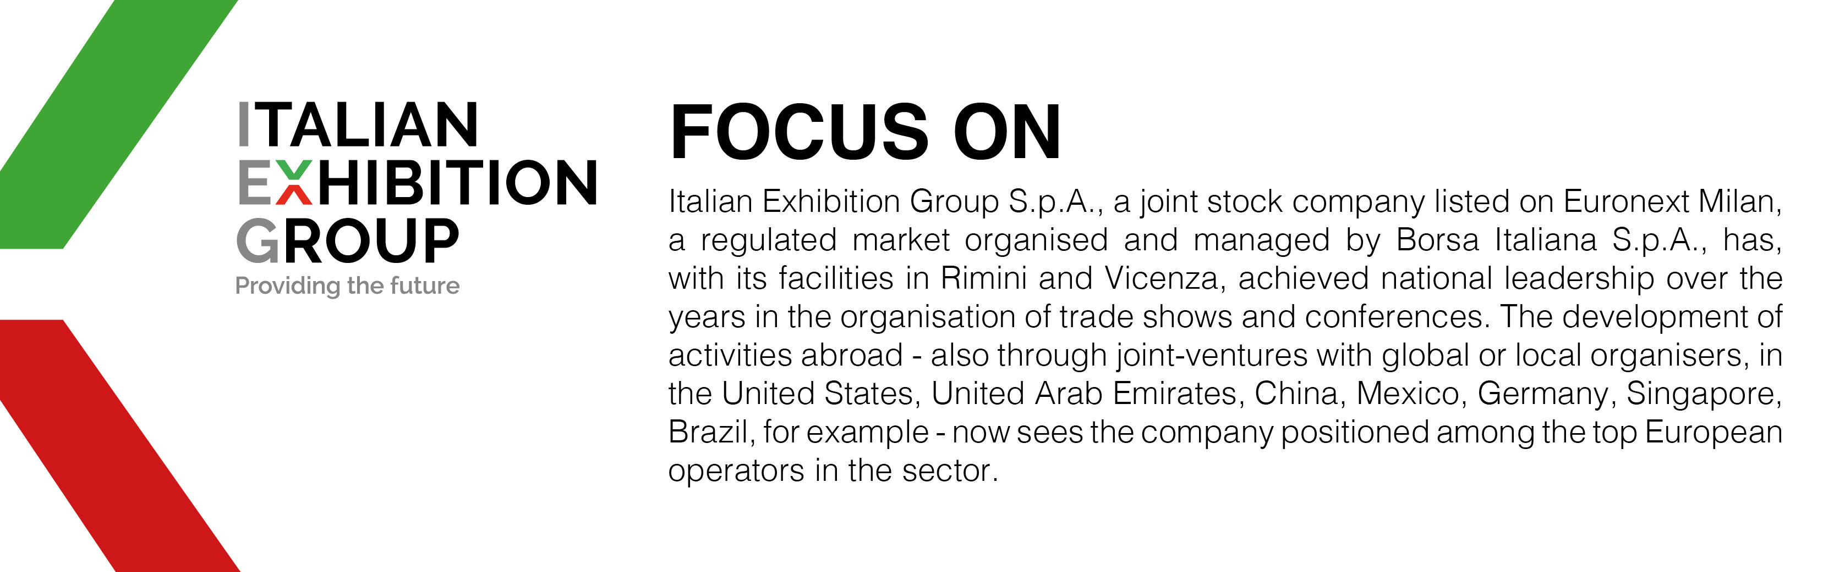

PRESS CONTACT ITALIAN EXHIBITION GROUP
Head of media relations & corporate communication: Elisabetta Vitali
Press office manager: Marco Forcellini

MEDIA AGENCY MIR
Naper Multimedia| Zoe Perna | T. +39 02 97699600 | email: staff@napermultimedia.it

This press release contains forecast elements and estimates that reflect the management’s current opinions (“forward-looking statements”), particularly regarding future management performance, realization of investments, cash flow trends and the evolution of the financial structure. For their very nature, forward-looking statements have a component of risk and uncertainty, as they depend on the occurrence of future events. The effective results may differ (even significantly) from those announced, due to numerous factors, including, only by way of example: food service market and tourist flow trends in Italy, gold and jewellery market trends, green economy market trends; the evolution of raw material prices; general macroeconomic conditions; geopolitical factors and evolutions in the legislative framework. Moreover, the information contained in this release does not claim to be complete, and has not been verified by independent third parties. Forecasts, estimates and objectives contained herein are based on the information available to the Company as at the date of this release.

